T23 R3

用时：21分05秒

做题情况：

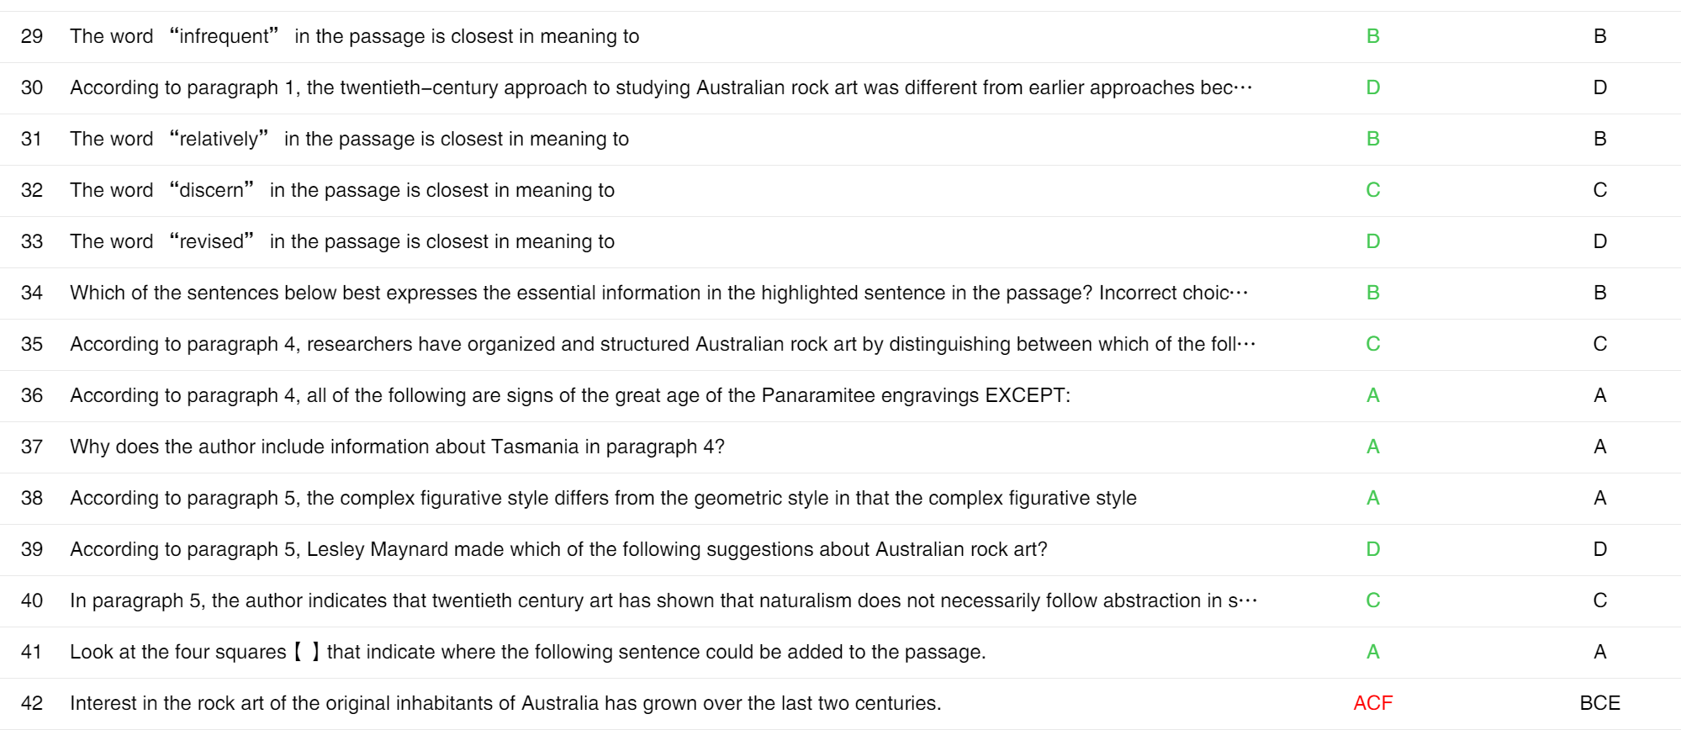

生词：

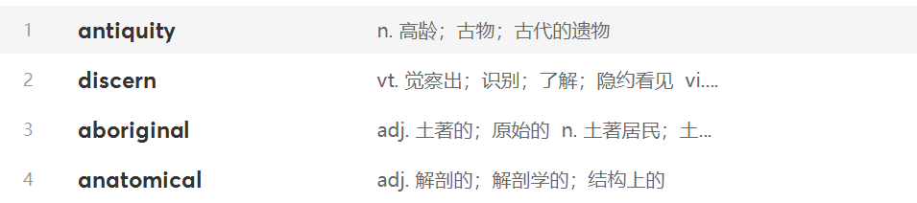

词组：

Give way to 给……让路，被……取代

长难句分析：

(In order to create a sense of structure to this picture,) researchers have relied on a distinction (that still underlies the forms of much indigenous visual culture)—a distinction between geometric and figurativeelements.) (Simple geometric repeated) patterns—(circles, concentric circles, and lines)—constitutethe iconography (characteristic images) (of the earliest rock-art sites found across Australia.)

Certain features (of these engravings) lead to the conclusion that they are of great age—geological changes had (clearly) happened (after the designs had been made) and local Aboriginal informants, (when first questioned about them,) seemed to know nothing (of their origins.)

错题情况：

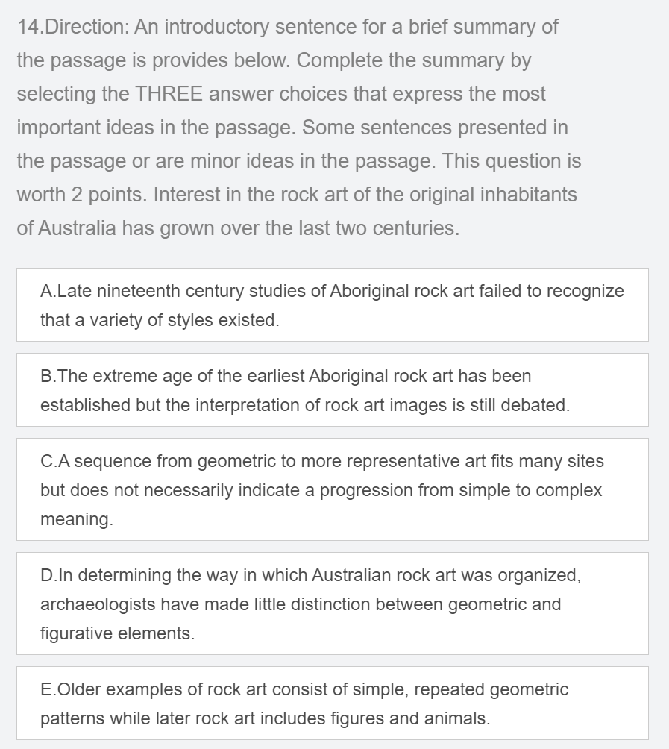

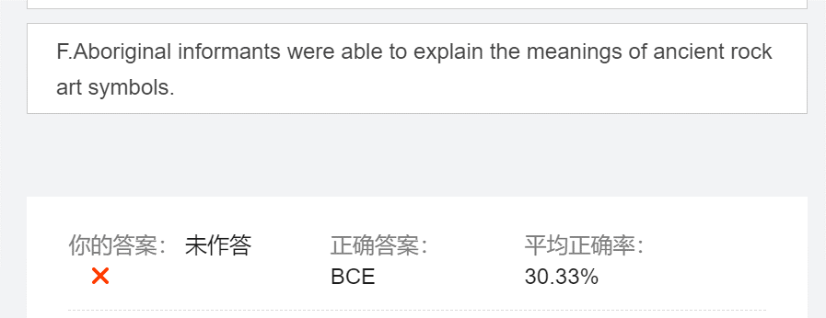

正确答案：BCE

我的答案：ACF

正确做法：B在原文中对应第三段的内容，其说法在第四段的第一句。C很明显，不赘述，E选项在倒数第二段可以体现出来。同义替换为Simple geometric repeated patterns— circles, **concentric** circles, and lines—**constitute** the iconography (**characteristic** images) of the earliest rock-art sites found **across** Australia.以及Lesley Maynard, the archaeologist who coined the phrase “Panaramitee style,” suggested that a **sequence** could be **determined** for Australian rock art, in which a geometric style gave way to a simple **figurative** style (outlines of figures and animals), followed by a range of **complex** **figurative** styles that, unlike the pan-Australian geometric tradition, tended to be much greater regional **diversity**.

文章分析：第一段提出研究澳大利亚岩壁，第二段提出几个要解决的问题，第三段提出一个问题（有多古老）的解答，第四段解释另一个问题仍有争议的原因是什么，第四段的论证很有问题，中心思想并不明确（也有可能我没有理解）。最后一段提出学说的进展，说这个是由简单到复杂的，但是也受到了其他人的质疑。

错误原因：我把E选项当成了细节，以为它并没有被很仔细的阐述。因此选错；至于B选项我看到第三段第一句，它说the age … is continually revised，所以我以为还没有established。